**Ideation Phase**

**Empathize & Discover**

|  |  |
| --- | --- |
| Date | 27 June 2025 |
| LTVIP2025TMID59793 | LTVIP2025TMID41423 |
| Project Name | Pattern Sense: Classifying Fabric Patterns using Deep Learning |
| Maximum Marks | 4 Marks |

**Empathy Map Canvas:** An empathy map is a simple, visual tool that helps us understand the thoughts, feelings, behaviors, and needs of textile manufacturers, designers, and quality assurance professionals responsible for identifying and managing fabric patterns.

For our machine learning–based fabric pattern classification system, this map helps us build deep empathy with users—factory operators, design teams, and quality control managers—so we can design a tool that is not only accurate, but also trustworthy, accessible, and meaningful in real production environments.

By exploring their frustrations, motivations, challenges, and interactions with current manual or semi-automated classification processes, we ensure that our solution addresses real-world problems and supports efficient production workflows, consistent quality, and better operational outcomes

**Example: Pattern Sense: Classifying Fabric Patterns using Deep Learning**

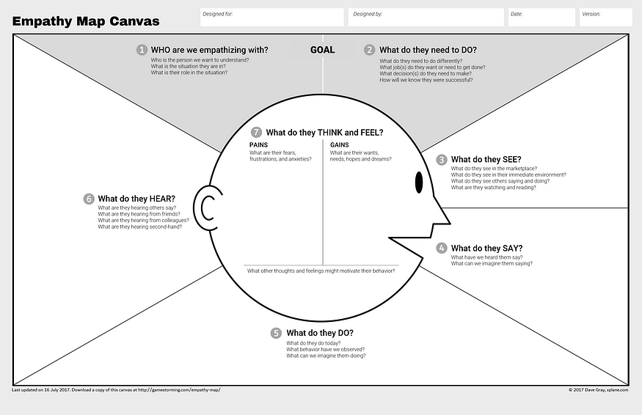

This empathy map captures the lived experiences, challenges, and aspirations of textile manufacturers, designers, and quality control teams who are responsible for classifying and managing fabric patterns, as well as the expectations of clients and end customers. It is designed to inform the development of a machine learning–powered pattern recognition and classification tool.

Through this map, we gain a deeper understanding of the practical and emotional pain points of stakeholders—such as concerns about misclassification, time-consuming manual processes, inconsistent labeling, and the impact of errors on production timelines—and their hopes for accurate, fast, and scalable solutions that integrate seamlessly into existing workflows.

By documenting:  
• **What users think and feel** (“What if the system misclassifies a design and delays production?”),  
• **What they hear** (“This sample doesn’t match the approved pattern”),  
• **What they say and do** (“We spend hours cross-checking every batch manually”),  
• **What they need to do** (standardize processes, improve efficiency, reduce human error),

...we’re able to design solutions that align with real-world needs and operational drivers.

This exercise helps ensure that the deep learning model we build is not just technically accurate, but also user-centered, trustworthy, and practical—enabling manufacturers and designers to classify patterns quickly, maintain quality standards, and meet production deadlines with confidence.